# PM2

## Project and Team

Project Name: **CarGenie**

Team Name: **HuskyAutoCoders** (Team 4)

Team Members:

- Yun Chen Chang

- Jinpeng Liu

- Luwei Fang

- Qiuying Zhuo

- Wen Xie

- Zhe Zhang

- Ziqi Liu

Reference to PM1: [PM1](https://docs.google.com/document/d/1gjREEfOMyCWx_K2DIqv8zDLRQRgHMfI71NrNcuou1_Y/edit?tab=t.0)

Dataset used: [Kaggle Used Cars Dataset](<https://www.kaggle.com/datasets/austinreese/craigslist-carstrucks-data>)

## Create Table Statements

```sql

-- Make sure the database exists

CREATE SCHEMA IF NOT EXISTS CarGenieDB;

USE CarGenieDB;

-- Include DROP TABLE IF EXISTS statements at the top so the relational model can be easily recreated

DROP TABLE IF EXISTS Images;

DROP TABLE IF EXISTS Locations;

DROP TABLE IF EXISTS VehicleSpecs;

DROP TABLE IF EXISTS VehicleConditions;

DROP TABLE IF EXISTS VehicleClassification;

DROP TABLE IF EXISTS Vehicles;

DROP TABLE IF EXISTS Models;

DROP TABLE IF EXISTS Manufacturers;

DROP TABLE IF EXISTS Regions;

DROP TABLE IF EXISTS States;

-- CREATE TABLE statements for all tables

CREATE TABLE States (

StateId INT AUTO_INCREMENT,

StateName VARCHAR(5) UNIQUE,

CONSTRAINT pk_States_StateId PRIMARY KEY (StateId)

);

CREATE TABLE Regions (

RegionId INT AUTO_INCREMENT,

RegionName VARCHAR(50),

StateId INT NOT NULL,

CONSTRAINT pk_Regions_RegionId PRIMARY KEY (RegionId),

CONSTRAINT uq_Regions_RegionName_StateId UNIQUE (RegionName , StateId),

CONSTRAINT fk_Regions_StateId FOREIGN KEY (StateId)

REFERENCES States (StateId)

ON UPDATE CASCADE ON DELETE CASCADE

);

CREATE TABLE Manufacturers (

ManufacturerId INT AUTO_INCREMENT,

ManufacturerName VARCHAR(50) UNIQUE,

CONSTRAINT pk_Manufacturers_ManufacturerId PRIMARY KEY (ManufacturerId)

);

CREATE TABLE Models (

ModelId INT AUTO_INCREMENT,

ModelName VARCHAR(255),

ManufacturerId INT,

CONSTRAINT pk_Models_ModelId PRIMARY KEY (ModelId),

CONSTRAINT fk_Models_ManufacturerId FOREIGN KEY (ManufacturerId)

REFERENCES Manufacturers (ManufacturerId)

ON UPDATE CASCADE ON DELETE SET NULL

);

CREATE TABLE Vehicles (

VehicleId BIGINT UNIQUE,

Vin VARCHAR(50) UNIQUE,

Price INT,

PostingDate DATE,

Description TEXT,

ModelId INT,

CONSTRAINT pk_Vehicles_VehicleId PRIMARY KEY (VehicleId),

CONSTRAINT fk_Vehicles_ModelId FOREIGN KEY (ModelId)

REFERENCES Models (ModelId)

ON UPDATE CASCADE ON DELETE CASCADE

);

CREATE TABLE VehicleSpecs (

VehicleId BIGINT,

Cylinders VARCHAR(50),

Fuel ENUM('GAS', 'DIESEL', 'ELECTRIC', 'HYBRID', 'OTHER'),

Transmission ENUM('AUTOMATIC', 'MANUAL', 'OTHER'),

Drive ENUM('FWD', 'RWD', '4WD'),

CONSTRAINT pk_VehicleSpecs_VehicleId PRIMARY KEY (VehicleId),

CONSTRAINT fk_VehicleSpecs_VehicleId FOREIGN KEY (VehicleId)

REFERENCES Vehicles (VehicleId)

ON UPDATE CASCADE ON DELETE CASCADE

);

CREATE TABLE VehicleConditions (

VehicleId BIGINT,

Odometer INT,

VehicleCondition ENUM('EXCELLENT', 'FAIR', 'GOOD', 'LIKE_NEW', 'NEW', 'SALVAGE'),

TitleStatus ENUM('CLEAN', 'LIEN', 'MISSING', 'PARTS_ONLY', 'REBUILT', 'SALVAGE'),

CONSTRAINT pk_VehicleConditions_VehicleId PRIMARY KEY (VehicleId),

CONSTRAINT fk_VehicleConditions_VehicleId FOREIGN KEY (VehicleId)

REFERENCES Vehicles (VehicleId)

ON UPDATE CASCADE ON DELETE CASCADE

);

CREATE TABLE VehicleClassification (

VehicleId BIGINT,

Year INT,

Size ENUM('COMPACT', 'MID-SIZE', 'FULL-SIZE', 'SUB-COMPACT'),

Type ENUM('BUS', 'CONVERTIBLE', 'COUPE', 'HATCHBACK', 'MINI-VAN', 'OFFROAD', 'OTHER', 'PICKUP', 'SEDAN', 'SUV', 'TRUCK', 'VAN', 'WAGON'),

Color ENUM('BLACK', 'BLUE', 'BROWN', 'CUSTOM', 'GREEN', 'GREY', 'ORANGE', 'PURPLE', 'RED', 'SILVER', 'WHITE', 'YELLOW'),

CONSTRAINT pk_VehicleClassification_VehicleId PRIMARY KEY (VehicleId),

CONSTRAINT fk_VehicleClassification_VehicleId FOREIGN KEY (VehicleId)

REFERENCES Vehicles (VehicleId)

ON UPDATE CASCADE ON DELETE CASCADE

);

CREATE TABLE Images (

ImageId INT AUTO_INCREMENT,

VehicleId BIGINT NOT NULL,

ImageURL VARCHAR(255),

CONSTRAINT pk_Images_ImageId PRIMARY KEY (ImageId),

CONSTRAINT fk_Images_VehicleId FOREIGN KEY (VehicleId)

REFERENCES Vehicles (VehicleId)

ON UPDATE CASCADE ON DELETE CASCADE

);

CREATE TABLE Locations (

VehicleId BIGINT,

Latitude FLOAT,

Longitude FLOAT,

RegionId INT,

CONSTRAINT pk_Locations_VehicleId PRIMARY KEY (VehicleId),

CONSTRAINT fk_Locations_VehicleId FOREIGN KEY (VehicleId)

REFERENCES Vehicles (VehicleId)

ON UPDATE CASCADE ON DELETE CASCADE,

CONSTRAINT fk_Locations_RegionId FOREIGN KEY (RegionId)

REFERENCES Regions (RegionId)

ON UPDATE CASCADE ON DELETE CASCADE

);

**UML:**

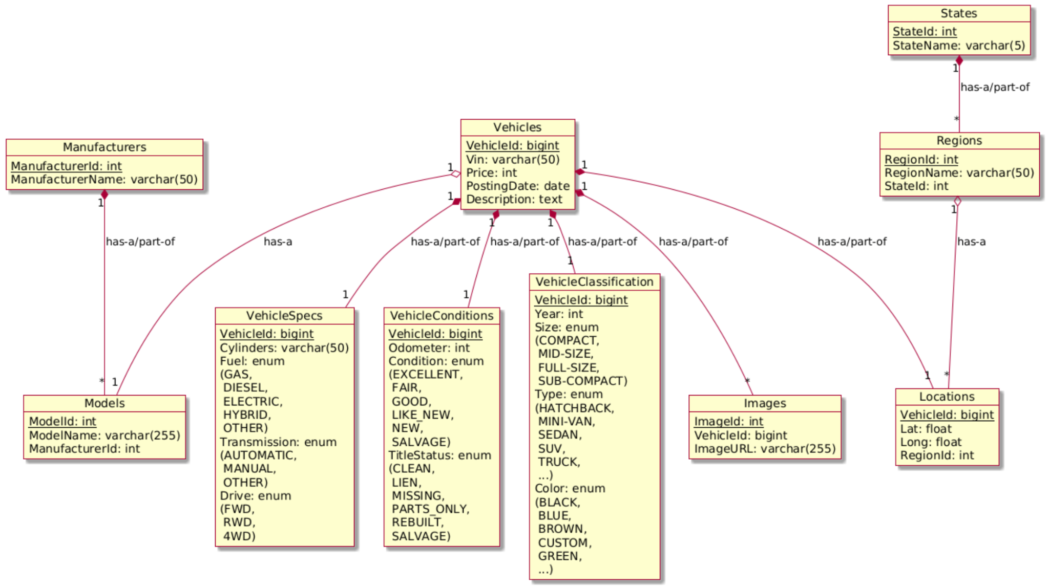

- **Manufacturers** – Table storing vehicle manufacturer data

- **Models** – Table containing vehicle model information

- **Vehicles** – Core table containing vehicle details

- **VehicleSpecs** – Table for detailed vehicle specifications (engine type, drivetrain, etc.)

- **VehicleConditions** – Table tracking vehicle conditions (new, used, accident history, etc.)

- **VehicleClassification** – Table categorizing vehicles (sedan, SUV, truck, etc.)

- **Images** – Table storing URLs of vehicle images

- **Locations** – Table for vehicle geographic data (state, latitude, longitude)

- **Regions** – Table representing geographic regions

- **States** – Table of U.S. states information

**Row Count:**

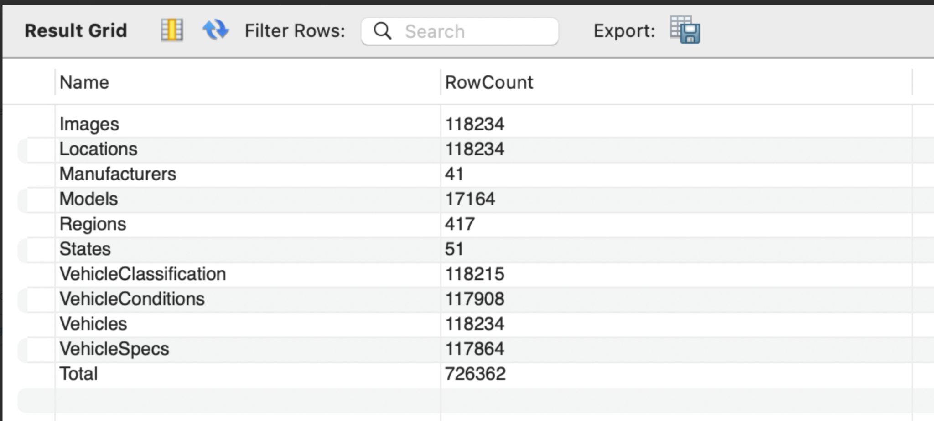

Total row count across all tables is above the 100K requirement.